DATASET FOR DAILY REPORT

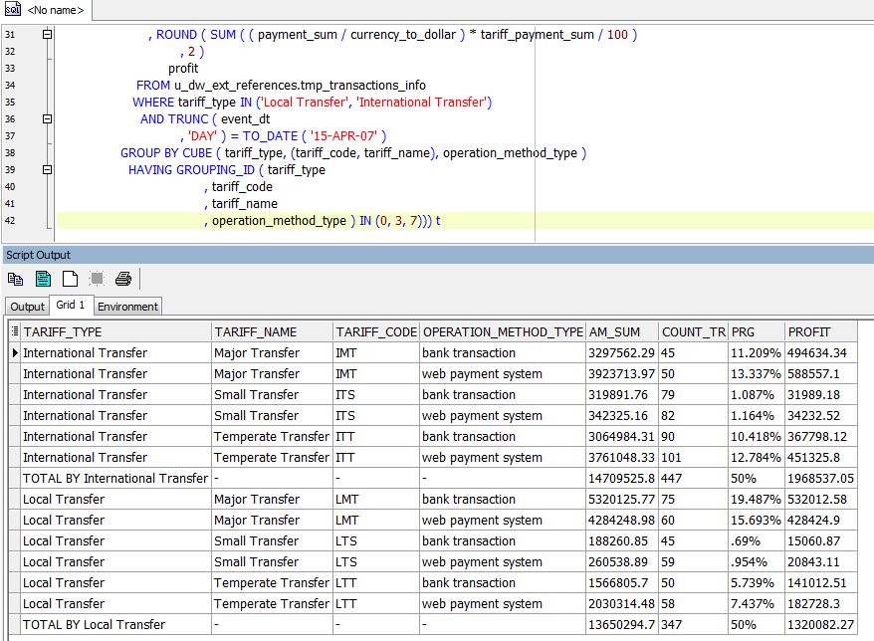

DATASET FOR MONTHLY REPORT

